Name: Mallela Kranthikumar
Batch: June 01, 2022
Tutor: Raham Shaik
Project: Integration of different tools with Jenkins
Project:
- Created EC2 instance for Jenkins server and installed java git and jenkins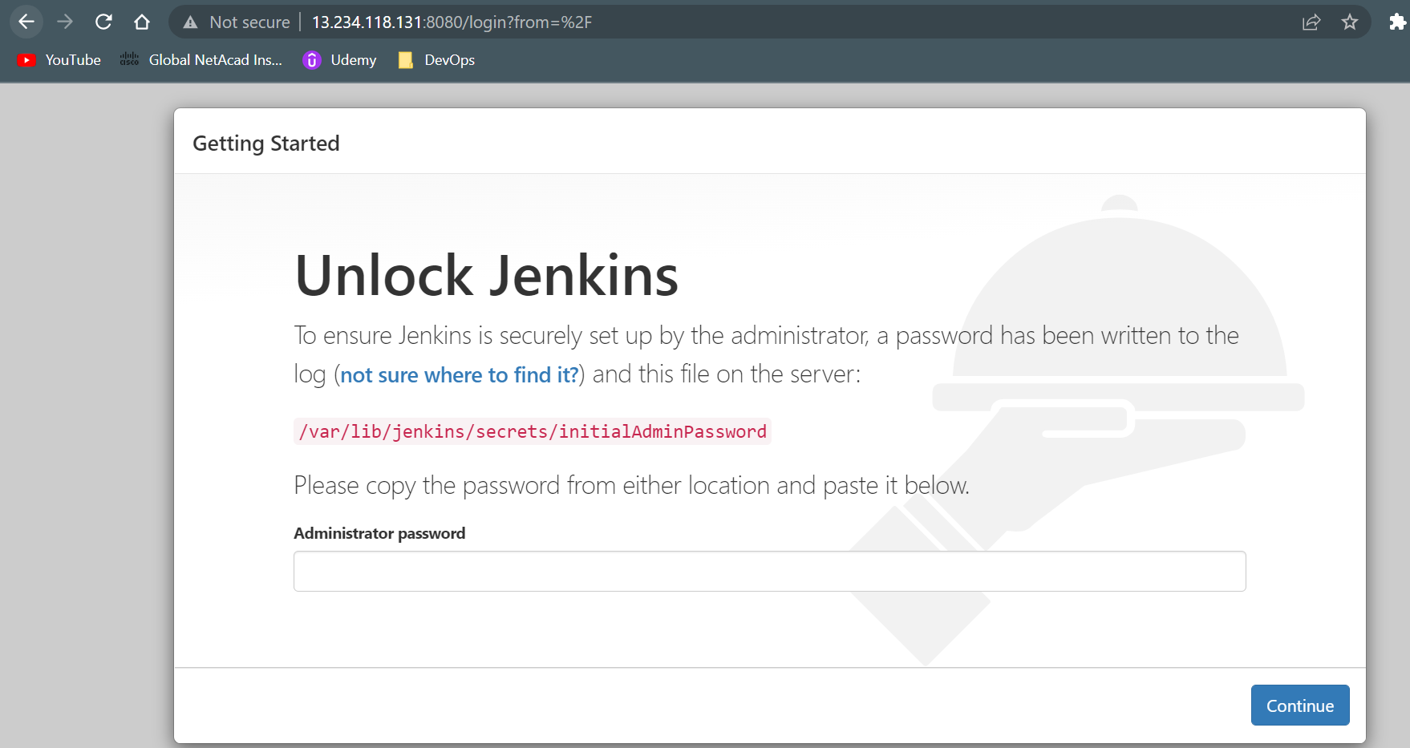
- Created tomcat server and installed Java and tomcat server in that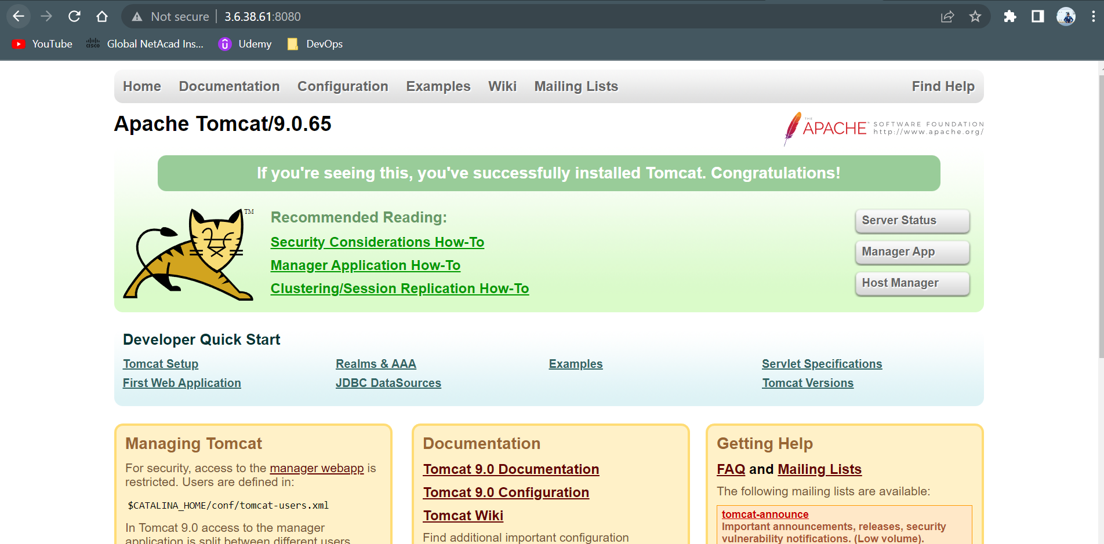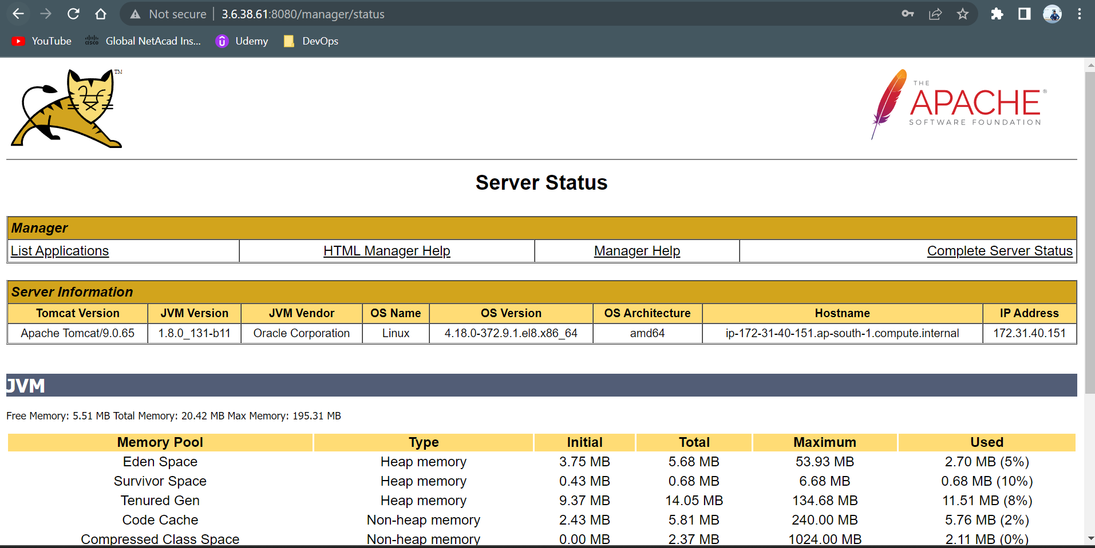
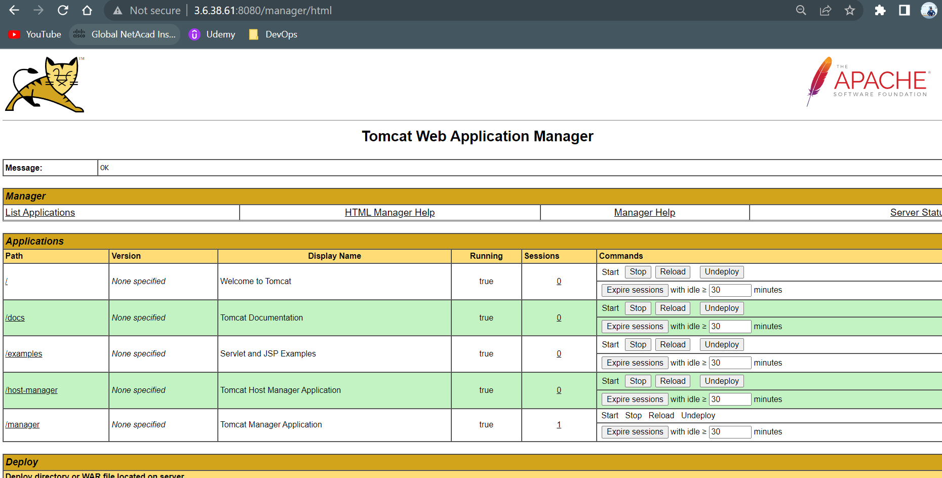
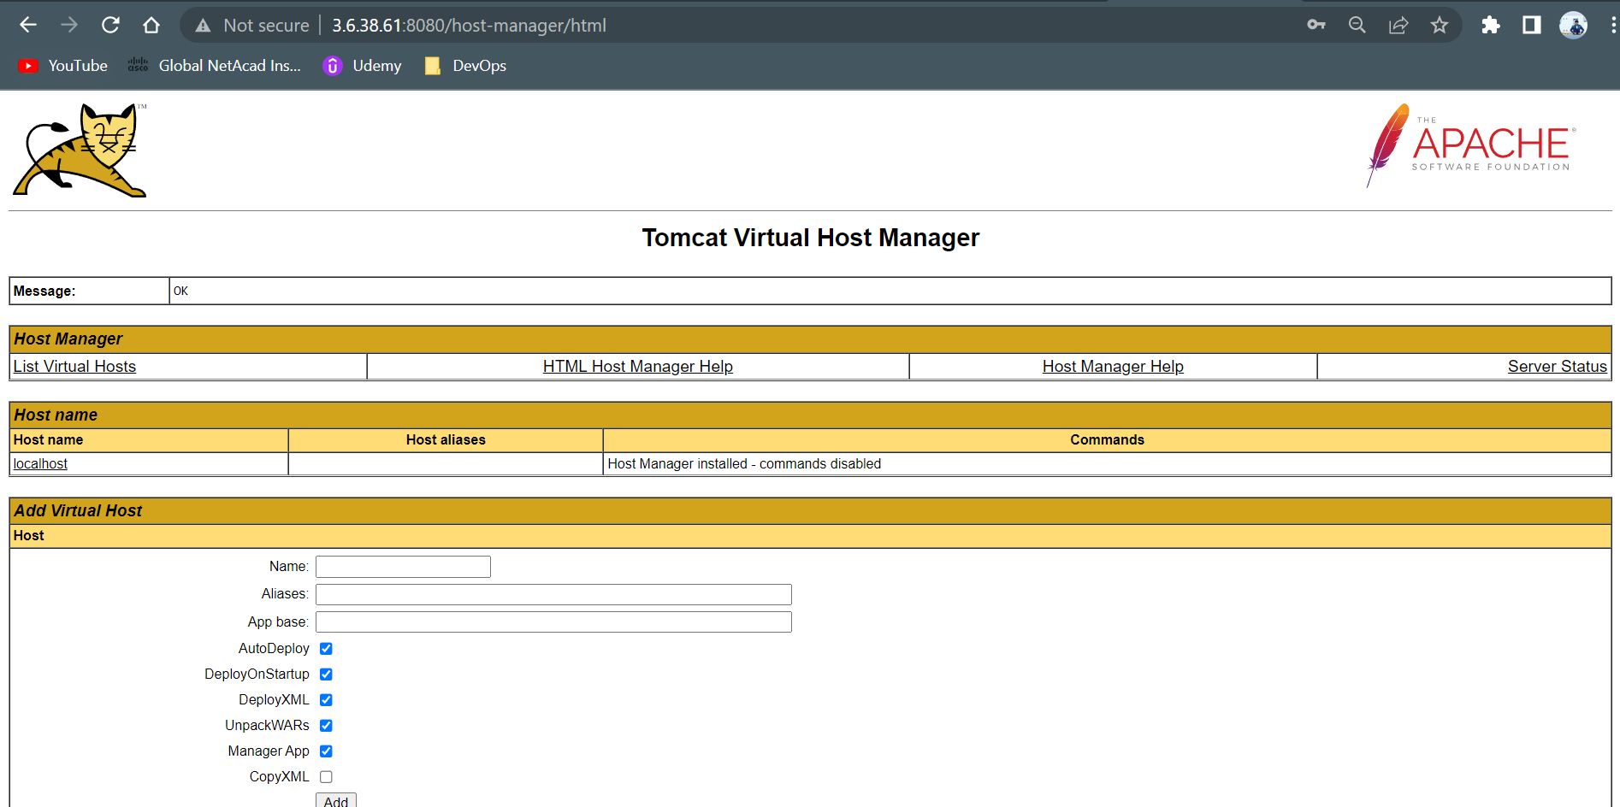
- Created EC2 instance and installed Maven Sonarqube and Nexus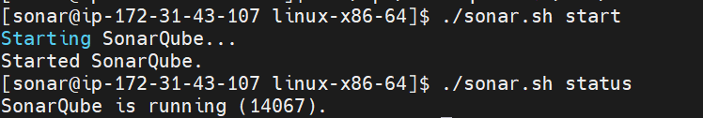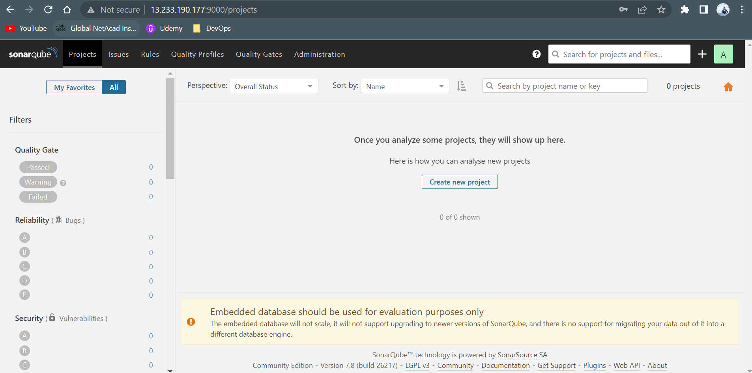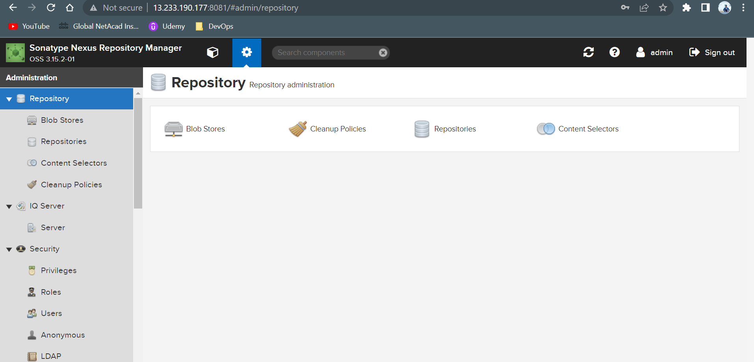
- Created Tokens in Sonarqube and nexus to use for authentication and created repo in nexus to store artifcats snapshot and releases
- Logged into Jenkins page and created a new project
- Integrated Github by adding repo url in source code management
- Integrated maven by installing maven in Jenkins by going to global tools cofnig and added maven version
- In project configured maven and added maven goals like clean package sonar:sonar to create a package and code quality report in sonar qube.
- Sonarqube details are configured in pom.xml of project and token was added for authentication
- Nexus details configured in pom,xml and credentials configures in settings.xml under conf in maven clean deploy was applied in maven goals
- Build the job and the job was success

